GLOVES
The choice of gloves will depend on:

- Expected exposure to infectious agents and chemicals (fit, where long-sleeved gloves provide the best protection, and barrier properties)
- Section 8.2 of the safety data sheet for your chemicals provides information on what kind of protective gloves are recommended.
- Personal circumstances (allergies, size)
- The type of work to be carried out can affect, for example, whether the gloves provide good enough friction, or protection against puncture injuries or cold.
- Consider whether colour is important, for example different colour in a polluted area/work with hazardous substances and in a clean area/work with non-hazardous substances.
- When working with hazardous substances, it may be appropriate to wear double gloves to increase resistance/safety against this.
Latex gloves offer good protection against penetration by microorganisms and chemicals and have good tensile strength and fit. However, latex is a known allergen.
Nitrile gloves , like the latex glove, provide good protection against the penetration of chemicals. The gloves have better barrier properties against some substances, such as acrylates. Nitrile is considered gentler on sensitive skin, but can also cause skin irritation. To prevent contact dermatitis and allergies, accelerator-free nitrile gloves are recommended.
Vinyl gloves have poorer barrier properties to infection and many chemical substances, poorer tensile strength and fit, and provide poorer protection than latex and nitrile gloves. Vinyl gloves should only be used in situations where requirements for barrier properties, fit and dexterity are low.

Requirements for gloves
They must be CE marked, and certified by an approved institute (here: 2777).
AQL (Acceptable Quality Level): At a stated value of ≤ 1.5, which means that there can be up to 1.5 gloves with holes per 100 gloves. In work situations with a high risk of infection or hazardous chemicals, gloves with a low AQL and possibly double gloves should be used.
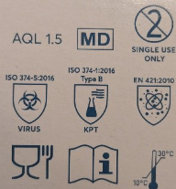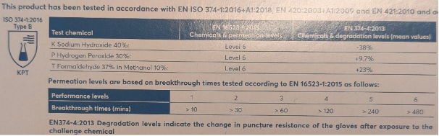
The EN standard that may have been used, and the level of protection, such as the classification of protective gloves against chemicals up to the penetration time.
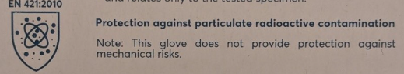
There are separate EN standards, for example for Static Electricity (EN60903), Cold (EN511), Ionizing Radiation (EN421), etc. Below is a review of one of the ones that affects us most in everyday life in the laboratory:
In situations where a higher degree of protection is required, for example when handling cytostatic agents and when contact with chemicals is expected, gloves approved in accordance with the standard for protective gloves against chemicals and microorganisms should be worn: EN-374 (5 parts):
1: Terminology and performance requirements for protection against hazardous chemicals (EN 374-1)

2: Penetration resistance (EN 374-2)
Tests that the glove is completely tight. On disposable gloves, the glove is tested by filling it with water or air, if it leaks out, the glove is defective. The value for this can be stated in AQL level.

3: Penetration resistance of liquid chemicals (EN 16523-1 (replaces EN 374-3))
Measures how long it takes for chemicals to penetrate the glove at a molecular level (under constant contact, at 25°C). The performance level ranges from 1-6 where level 1 has a breakthrough time of >10 min while level 6 has >480 min.

Remember that when you use the gloves, they will get body temperature, and the penetration time may then be shorter. Therefore, change gloves well in advance of the specified penetration time!

The list of chemicals on which the gloves can be tested:
 | CHEMICAL | CAS | CLASS
A | Methanol | 67-56-1 | Primary alcohol
B | Acetone | 67-64-1 | Ketone
C | Acetonitrile | 75-05-8 | Nitrile compound
D | Dichloromethane | 75-09-2 | Chlorinated kerosene
E | Carbon Disulfide | 75-15-0 | Organic sulphur compound
F | Toluene | 108-88-3 | Aromatic hydrocarbon
G | Diethylamine | 109-89-7 | Amen
H | Tetrahydrofuran | 109-99-9 | Heterocyclic and etheric connection
I | Ethyl Acetate | 141-78-6 | Ester
J | n-Heptane | 142-82-5 | Saturated hydrocarbon
K | Sodium hydroxide 40% | 1310-73-2 | Inorganic base
L | Sulfuric acid 96% | 7664-93-9 | Inorganic mineral acid, oxidizing
M | Nitric acid 65% | 7697-37-2 | Inorganic mineral acid, oxidizing
N | Acetic acid 99% | 64-19-7 | Organic Acid
O | Ammonium hydroxide 25% | 1336-21-6 | Organic base
P | Hydrogen peroxide 30% | 7722-84-1 | Peroxide
S | Hydrogen fluorosy 40% | 7664-39-3 | Inorganic mineral acid
T | Formaldehyde 37% | 50-00-0 | Aldehyde

The result of the test classifies the gloves as Type A, B or C under EN 374-1.
EN 374-1: Type A – Minimum 6 chemicals must achieve at least performance level 2 (>30 min).
EN 374-1: Type B – Minimum 3 chemicals must achieve at least performance level 2 (>30 min).
EN 374-1: Type C – Minimum 1 chemical must achieve at least performance level 1 (>10 min).
The chemicals the glove has been tested for are shown in a letter code. Example:
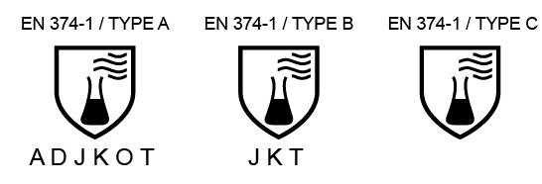
Keep in mind that the manufacturer's data applies to pure chemicals, not mixtures.

4: Resistance to chemical degradation (EN 374-4)
In this test, the change in one or more protective properties of the glove due to contact with the chemical against which the glove is being tested is measured. The test measures the change in % of the puncture resistance of the glove before contact with the chemical (for one hour) and after.
5: Protection against microorganisms (EN 374-5)
This test measures the protection the glove has against fungi, bacteria and viruses. The packaging of the glove is marked with the pictogram for microbiological hazard for gloves that protect against fungi and viruses. If the glove also satisfies the requirements of the virus test method, it will say VIRUS under the pictogram.

Risk factors related to glove use
- The use of gloves can give personnel a perception of reduced risk of infection/exposure to their own person, and studies show that the use of gloves reduces compliance with hand hygiene recommendations. https://vimeo.com/205862286?fl=pl&fe=cm
- Improper use of gloves increases contamination of the environment by touching inventory and equipment with unclean gloves.
- Indiscriminate use of gloves also leads to an increased incidence of skin irritation. Hand washing after wearing gloves reduces the risk of contact dermatitis and allergies, as residual chemicals are removed from the glove.
- Unnecessary use of gloves also increases the burden on the environment.

