Welcome to G Travel!
DIFI has entered into a new travel agency framework agreement for its enterprises. The University of Bergen - UIB will be served by G Travel, and we ask that you take a few minutes to read the information below.
We have already created a profile for you with your NAME AND EMAIL ADDRESS. It is important that you yourself register a CREDIT CARD the first time you log in, as this will be used as the means of payment for your travels. You have to register your mobile phone number.
You may also specify any personal preferences.
Logging in to G Travel Online in browser, tablet and mobile
- Go to the following website: https://gtravelonline.softinventor.com
Click on Feide, and use the same password as you use when you log on to UiB

- To update your profile with a credit card or personal preferences, click the icon in the upper right corner of the screen.

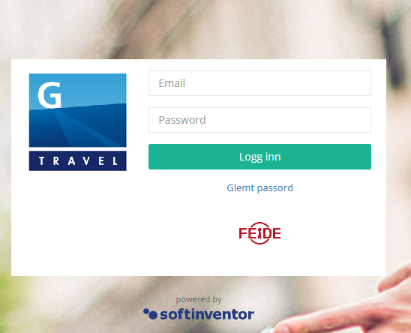

It is your own responsibility that your profile information is correct at any time. The name in your profile should be the same as in your passport. We ask that you check this the first time you log in.

To receive notifications and check-in from airlines it is important that the email address and mobile phone number in your profile are correct. Remember to update your profile if you start using a new credit card, and with any other changes.
A User Manual can be found by clicking the icon in the upper right corner. It will take you through the booking procedure, step by step. If you have any other questions regarding our website, please contact our online support.

G Travel Online Support.
Questions regarding login and profile updates in G Travel Online will be answered by contacting our online support. You can also watch our instruction video (about 10 minutes).

Link: https://www.youtube.com/watch?v=1XHjN2hch6Y&feature=youtu.be (instruction video)

Email: online.aes@gtravel.no
Phone: +47 71 24 59 63

Travel consultants (business travel)
For personalised service and effective guidance for booking complicated journeys, we recommend contacting one of our skilled consultants by phone or email. Our opening hours are Monday-Friday, 07.00 – 18.00. If you contact us outside these hours you will automatically be transferred to our 24-hour service.

Phone: +47 71 24 59 63
Email: uib@gtravel.no

Group & Meeting
Our Group & Meeting department has long-standing experience in facilitating and tailoring arrangements, conferences, events and group-travel both nationally and internationally.

Phone: +47 70 10 01 80
Email: groups.aes@gtravel.no

Visa service
G Travel has a separate department for Visa applications, which will give you all necessary information in one place, quickly, effectively and accurately.

Phone: +47 71 24 59 63
Email: uib@gtravel.no.

We look forward to working with you!

Best regards,
Anne May Bratteberg
Key Account Manager - DIFI
amb@gtravel.no | Mobile: +47 911 02 800

