**Invitasjon til UiB sin andre årlige læringskonferanse 2016:**

**Motivasjon for læring i høyere utdanning**

***Program:***

**Torsdag 20 . oktober 2016**

**8.30 – 9.00 Registrering/kaffe**

**9.00 – 10.30 Plenumsforedrag: Edward L. Deci**

Promoting Optimal Motivation in Higher Education: A Self-  Determination Perspective

**10.30 – 10.45  Pause**

**10.45 – 11.20** Flipped classroom: Erfaringer fra et kurs i produktutvikling

**Herbjørn Nysveen,** professor, Institutt for strategi og ledelse, NHH

**Arild Raaheim,** professor, Institutt for pedagogikk, UiB

**11.20 – 12.00** Hvilke effekter har teknologi på studentenes motivasjon og

Læring?

**Lucas Jeno,** stipendiat, Institutt for biologi, UiB

**12.00 – 13.00  Lunch**

**13.00 – 15.00  Workshop: Self-Determination Theory: Edward L. Deci**

**Presentasjon av keynote:**  
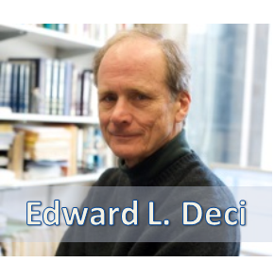

Edward L. Deci is a Professor of Psychology and Gowen Professor in the Social Sciences at the University of Rochester, and director of its human motivation program. He is well known in psychology for his theories of intrinsic and extrinsic motivation and basic psychological needs. With Richard Ryan, he is the co-founder of self-determination theory (SDT), an influential contemporary motivational theory. Self-determination theory is a macro theory of human motivation that differentiates between autonomous and controlled forms of motivation; the theory has been applied to predict behavior and inform behavior change in many contexts including: education, health care, work organizations, parenting, and sport. (Wikipedia)