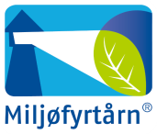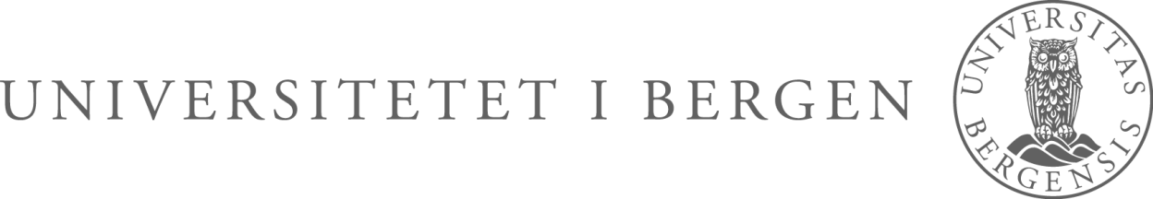

The Faculty of Medicine and Dentistry arranges a Career Day for PhD candidates and postdoctors at the faculty.

**PROGRAM FOR THE DAY**

**10.00 – Welcome by Professor and Vice Dean for research education –**

**Roland Jonsson, the Faculty of Medicine and Dentistry**

**10.15 – CV and application writing – Rønnaug Tveit, Career Centre**

**11.00 – My way! Presentations from former PhD candidates**

**from the faculty**

* **Bengt Åge Borge – advisor in environmental health, Askøy Municipality**
* **Arnt Ove Hovden – Medical Manager, Boehringer Ingelheim Norway**
* **Vibeke Ansteinsson – research leader, Centre of Competence East**
* **Mette Tollånes – chief physician at Norwegian Institute of Public Health (Folkehelseinstituttet)**

**12.15 – Lunch and stands from Bergen University College, University of**

**Bergen, Norwegian Institute of Public Health,**  **Boehringer**

**Ingelheim, Centre of Competence East, Helse Bergen, Bergen**

**Municipality, NIFES**

**14.00 – End of program**

CAREER DAY

Thursday 6 October at 10-14 AUD 4 BB-building