In July Brith Bergum took over as the daily manager of the Flow Cytometry Core Facility after Marianne Enger.

Brith has a background as a technician from Sars International Center for Marine Molecular Biology were she worked from 2009 to 2011. Subsequently she took a Masters Degree in Medical Cell Biology at Broegelmann Research Laboratory, at the Department of Clinical Science, UiB. After finishing her degree in 2013, she has worked as a Department Engineer in the Post Translational Modification group at the Broegelmann Research Laboratory.

If anyone has any questions or just want to come and say hello, you will find her at the 5th floor in the laboratory building.

Picture: http://www.uib.no/personer/Brith.Bergum
Kjernefasilitetet I Flow Cytometry : http://www.uib.no/en/clin2/flow

The Flow Cytometry Core Facility has a new cell sorter from SONY.
The SH800 is a bench top high-speed multilaser flow cytometer and cell sorter, designed to be affordable and easy to use.

The cell sorter has a total of 8 parameters,including forward and back scatter, and 6 fluorescent parameters. The cell sorter also has an extra filter set especially for detecting fluorescent proteins such as GFP, RFP and YFP.

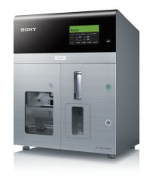
The SH800 has a 488nm and 561nm laser, making it optimal for simple cell sorting using e.g GFP/PE/Pe-Cy7 and mCherry.
The SH800 can do cell sorting two ways, in 96 well plates, slides and in 8 well strips.

Due to the SH800s automatic setup and its easy to use features, the SH800 is available for individual training and use.
The Sony SH800 is now in the MIC booking system.

For training and questions please contact
Brith.Bergum@uib.no or come visit me at the 5th floor in the laboratory building.

