The Department of Biological and Medical Psychology welcomes everyone to the symposium:

Sex Differences in Cognitive Skills
Do they exist? How do they arise? And what do they mean for society?

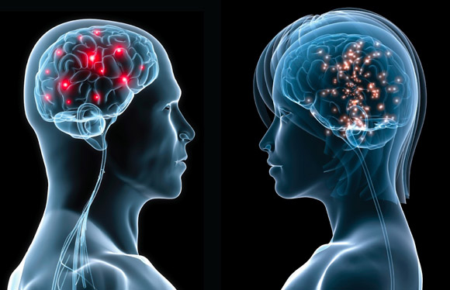

Studentsenteret, Auditorium (Egget)
10th June 2015, 9:00-16:00
9:15 | Welcome (Marco Hirnstein, University of Bergen)
9:30 | Diane Halpern, Minerva Schools at Keck Graduate Institute, San Francisco, USA  “Sex Differences in Cognitive Abilities: New Data, New Theories, New Conclusions”  Abstract: One of the most controversial topics in psychology is how, how much, and why females and males differ in some cognitive abilities. How can we make sense of the data about cognitive sex differences, and even more importantly, how can we use these data appropriately and guard against their misuse in formulating public policies? I will briefly review over three decades of research on this topic, with an emphasis on what has changed and what has remained the same over this time span.
11:00 | Kenneth Hugdahl, University of Bergen  “Sex, brain, and cognition: A multidisciplinary dialogue”  Abstract: In my talk I will present a selective overview of how structural and functional neuroimaging, in particular using magnetic resonance imaging technologies have opened up a new window into sex differences, and how differences in cognitive performance between males and females may have brain structural and functional correlates, involving large portions of the brain. I will also provide some reflections on how such correlates could have evolved, ending my talk with data on sex differences in brain function in various mental disorders.
12:00 | Lunch break
13:15 | Markus Hausmann, Durham University, UK  “Neuropsychology of sex and gender – Are innate sex differences to blame for the failure of women to advance in science?”  Abstract: The number of women in science, technology, engineering, and mathematics (commonly abbreviated STEM) has significantly increased over the past years. However, women still remain the minority in STEM disciplines and the disparity widens along the educational-vocational continuum, starting at school and gradually increasing during professional (academic) life. There is an ongoing debate as to the source of this disparity and there seems to be a tenacious belief that “innate” sex differences in cognitive abilities may partly account for it, or at least that these differences can partly explain why significantly fewer females than males appear at the upper end of higher cognitive abilities that are required in STEM areas. This talk will give an overview of current research on neurocognitive sex differences and addresses this issue within a psychobiosocial approach.
14:15 | Angelica Moè, University of Padova, Italy  “Threatening or challenging environments, beliefs, and motivations”  Abstract: Gender differences in cognition depend on a range of dispositional and situational factors. Among the latter the most important are some experiential, task-related and person-related factors, such as gender roles, stereotypes and motivational beliefs. This presentation will focus on what can create a threatening or a challenging testing situation, mainly in mental rotation, where the gender gap is among the highest ever studied.
15:15 | Panel Discussion
16:00 | End

Diane F. Halpern is the Dean of Social Sciences at the Minerva Schools at KGI. She is a past president of the American Psychological Association and the Society for Teaching of Psychology. Diane has published hundreds of articles and over 20 books including, Thought and Knowledge: An Introduction to Critical Thinking (5th Ed., 2014); Sex Differences in Cognitive Abilities (4th ed.), and Women at the Top: Powerful Leaders Tell Us How to Combine Work and Family (co-authored with Fanny Cheung). Her other recent books include Psychological Science (4th ed. with Michael Gazzaniga and Todd Heatherton) and the edited book, Undergraduate Education in Psychology: A Blueprint for the Future of the Discipline.
Diane has been studying cognitive sex differences and similarities for over 25 years. Her most recent projects are the development of Operation ARA, a computerized game that teaches critical thinking and scientific reasoning (with Keith Millis at Northern Illinois University and Art Graesser at University of Memphis) and the Halpern Critical Thinking Assessment (Schuhfried Publishers) that uses multiple response formats, which allow test takers to demonstrate their ability to think about everyday topics using both constructed response and recognition formats.

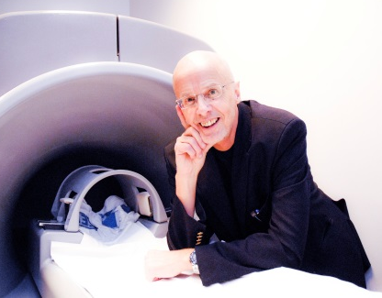
Kenneth Hugdahl is professor of biological psychology at the University of Bergen, and holds an adjunct position at the Division of Psychiatry, Haukeland University Hospital, Bergen. He is also the Head of the Bergen fMRI Group which pioneered functional imaging studies of the brain in Norway. Kenneth Hugdahl has published several hundred articles in his fields of research and has received several prizes and awards for his research.

Markus Hausmann is a Senior Lecturer in the Department of Psychology at Durham University, UK. His research interests include cognitive sex differences and intra- and interindividual differences in functional brain organisation. Markus has been studying cognitive sex differences and similarities for almost 20 years. He has published several research articles, book chapters and books on the neuropsychology of sex and gender. In his interdisciplinary research he aims to integrate psychological (personality traits), biological (hormonal and neuronal) and social factors (gender stereotypes) within a psychobiosocial approach.

Angelica Moè is Associate Professor at the Department of General Psychology at the University of Padova, Italy. Her research interests are gender motivational beliefs and mental rotation performance from childhood to adulthood, effectiveness of training to improve mental rotation performance, mental rotation and driving skills, academic achievement motivations and emotions.

