I was lucky to be chosen as the jury member for the Research School and have just completed three fabulous days where I experienced the vast wealth and quality of research conducted at K1/K2 and the hospital. These days were inspirational to experience the enthusiasm and love of research in so many of our young and talented researchers. On Wednesday, we evaluated 52 posters encompassing all fields of medicine. On Thursday, we listened to 22 oral presentations, which had a very high standard. After evaluation of nearly 75 different research projects in two days I was left feeling elated at the impressive quality and depth of research conducted at our campus. It was no easy job being on the jury and having to choose between these high quality presentations, from so many talented researchers. I would like to congratulate all of the participants with great presentations and prioritizing this important event in their busy schedules. One of my overriding feelings was that if I had been so lucky as a Ph.D. student to be able to present my work to colleagues at the same stage in their career and have positive feedback and meet and learn from so many other young medics and scientists I would have jumped at the chance, so please use your research school.
I learnt so much in these two days and for many of you it may well have been some of the best training in your career to communicate your fascinating research to a broad group of your peers in a safe friendly environment. I am already looking forward to next year and I strongly recommend that the everybody grabs the amazing chance that these two days of research school provide to meet new colleagues, impress other with your work and learn more than you will probably will in your whole Ph.D. please don't miss the opportunity next year and together make the research school a living school for everybody.

Prof. Rebecca Jane Cox K2 UiB/HUS

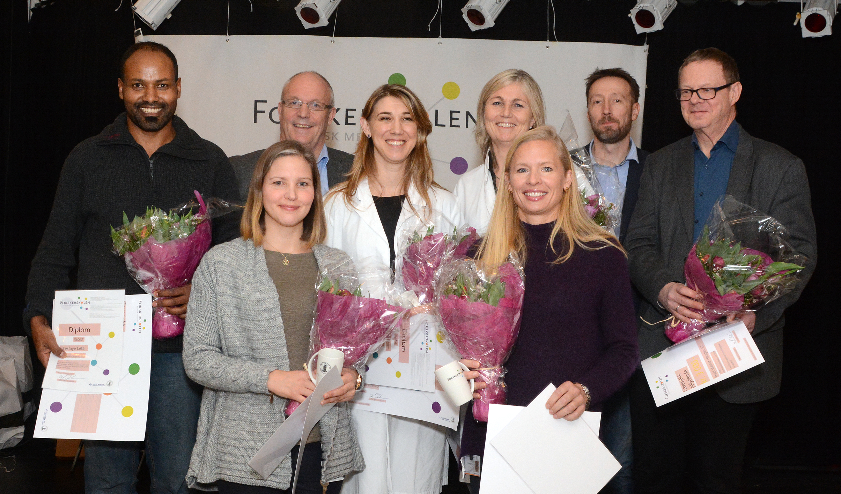
Photo Jørgen Barth UiB

