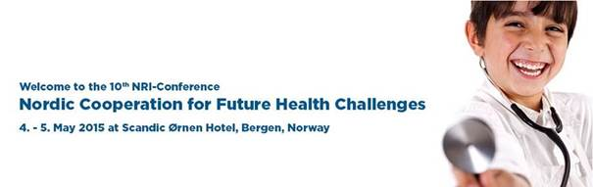

**Welcome to the 10th NRI-Conference:**

**Nordic Cooperation for Future Health Challenges**

**4. - 5. May 2015 at Scandic Ørnen Hotel, Bergen, Norway**

The NRI-Conference aims to provide a platform for discussion of new ideas as well as to contribute to stronger cooperation among professionals in the healthcare industry in the Nordic region.

This year, the NRI-Conference will explore health challenges and possibilities that lie ahead for the Nordic region. Our speakers armed with expertise will provide their perspectives to important questions for the future. How should Nordic region tackle challenges such as antibiotic resistance? How do we meet the increased importance of health innovation? How can the Nordic region utilize its competitive advantages? What is the best way to establish Nordic collaboration for clinical research and trials?

In 2014, the NRI-Conference gathered more than 170 participants. Because of the event expansion and growing popularity NRI-Networks has chosen to organize the conference in the newly opened Scandic Ørnen Hotel located in the heart of Bergen’s cultural scene.

**Highlights**

* Nordic Council of Ministers presents the Könberg Rapport: “The Future Nordic Co-operation on Health”
* Antibiotic resistance
* Clinical Research - How to Recapture the Position?
* The Norwegian Government’s Innovation Strategy
* The Role of Bioinformatics in Clinical Research
* Workshops in Nordic Innovation Network, Nordic Study Sites, Nordic Monitoring Network, Nordic Nurses Network and Nordic Pediatric Research
* Networking dinner

**Some of this year's expert speakers are:**

* **Anders Geertsen** - Head of Department, Nordic Council of Ministers
* **Pål Rasmus Njølstad** - Head of KG Jebsen Center for Diabetes Research, University of Bergen
* **Mats Ulfendahl** - Secretary General, Swedish Scientific Council for Medicine

[**More information and registration**](http://nordicnetworks.org/nri-conference/)

[**Download program**](https://djq5dn2anhxq9.cloudfront.net/1424264156/nri-conference-2015_program.pdf)

If you have any questions, please contact us at [info@nordicnetworks.org](mailto:info@nordicnetworks.org).

NRI-Networks is looking forward to seeing you in May!

Kind regards,

**Nordic Health Research and Innovation Networks - NRI Networks**



[**www.nordicnetworks.org**](http://www.nordicnetworks.org)