MedViz Conference 15 - 16 June 2015, Bergen
The MedViz Conference, entitled Innovation in Imaging & Visualization, will be arranged in Bikuben Conference Center at HUH campus in the period June 15-16, 2015, in close cooperation with Molecular Imaging Center (Dept. of Biomedicine) at UoB and Center for Nuclear Medicine /PET at HUH.
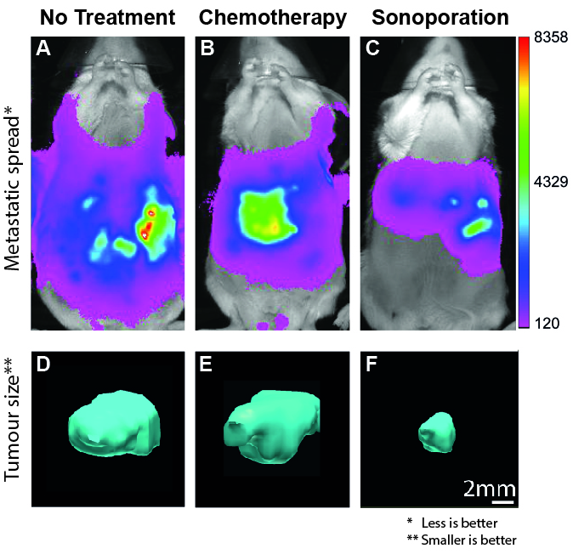
The Figure shows effect of chemotherapy and therapeutic ultrasound with microbubbles (Sonoporation) on metastatic spread (A-C) and primary tumour sizes (D-E). The untreated mouse has the worst metastatic spread (A), i.e., whole body spread. Treatment with chemotherapy showed decreased metastatic spread (A vs B), but no change in primary tumour size (D vs E). Combining chemotherapeutic and sonoporation, resulted primary tumours only growing to 25%, when compared to just chemotherapeutic alone ( D and E vs F). In addition, metastatic spread was limited to the liver (C). The colour grade expressing metastatic spread is measured as number of photon counts as a function of time and relates to “cancer cell concentration”. (Kotopoulis et al. 2013).
The conference is scheduled with the following seven sessions:
• PET & tracer development
• Technology & advanced visualization
• Biological & preclinical imaging
• Speed poster session
• Gastrointestinal imaging
• Pelvic imaging
• Neuro & brain imaging
Please, note the dates and more information will appear at www.medviz.no

