The 2014 Joint National PhD Conference in Medical Imaging and MedViz Conference

- Bergen, 17-18 June 2014
REGISTRATION:
For phd/postdoc/students: https://reg.app.uib.no/medviz2
For all others: https://reg.app.uib.no/medviz1
We are delighted to invite all PhD Candidates and other researchers in the field of medical imaging, image acquisition, modelling and visualization from all Norwegian institutions to join us in Bergen in June, to take part in the 2014 Joint National PhD Conference in Medical Imaging and MedViz Conference. In addition to an exciting scientific program, we invite you to cruise the waves of the Bergen fjords under the full white sails of the majestic ship "Statsraad Lehmkuhl"!
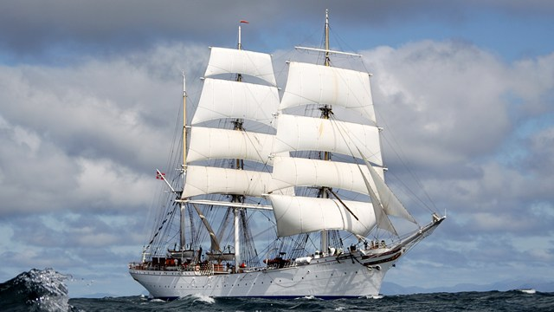Statsraad Lehmkuhl
As this year's conference is jointly organized with MedIm, we encourage principal investigators, supervisors and research oriented clinicians to join the PhD candidates. This conference has become an important annual meeting place for the whole field of medical imaging in Norway.
Travel grants to all participants with abstract who are registered as members of MedIm! Registration deadline: 23 April 2014. Abstract deadline: 11 May 2014.
Prizes of NOK 10,000 will be awarded for 'Best poster' and 'Best oral presentation'. In addition, a prize of NOK 5000 will be awarded for 'Best Scientific Image'
The number of participants is limited to 140. Participants will be accepted on a first-come, first-served basis. So, do not hesitate – register today!
In addition to scientific sessions with high profiled invited speakers, the program hosts an innovative form of poster presentation: Speed poster presentations. These sessions brings the poster presenters more in touch with the plenary audience.
There is no conference fee for PhD Candidates, Research Program students and post doc's who participate with an abstract. Participants in this group who are MedIm members, will also have their travel cost and their hotel accommodation covered by MedIm.
The conference dinner and social event will take place at the majestic ship "Statsraad Lehmkuhl".
MedViz also organize a pre-conference Workshop Monday 16th of June, chaired by two international speakers from UK and USA.

