Research Group for Pregnancy, Fetal Development and Birth (G16)

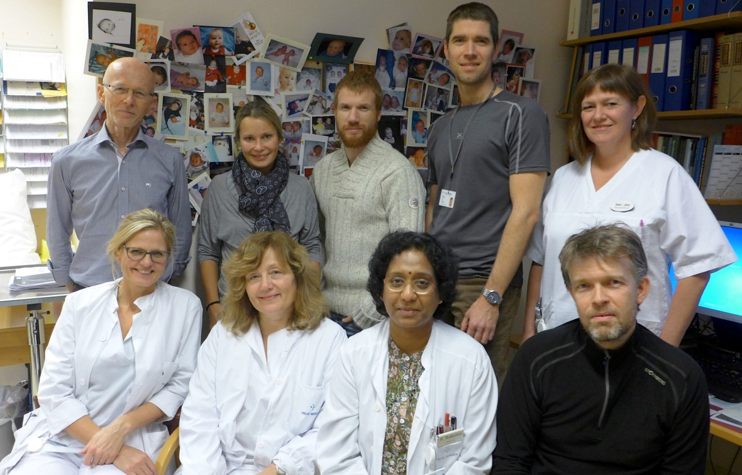

2/3 of the research group at site

The establishment of the research group

The fetus was the smallest and latest patient arriving at the medical arena when the ultrasound technology opened a window into pregnancy demanding new physiological basic information, diagnostics andtreatment options. At the Department of Obstetrics & Gynecology, Haukeland University Hospital, we focused fetal circulation and growth. The research group grew during the last 10-12 years by adding clinicians that carried out PhD-research and postdocs.
Epidemiology research, another important field for us, came about in collaboration with the Norwegian Birth Registry and is a longstanding tradition of the department. In recent years additional possibilities for registry-based research has expanded with the growing number of registries available, and our research within this field has added on correspondingly.
Global reproductive health is another area of research particularly aimed at reducing maternal mortality.

The activities of the research group

We study the fetus using Doppler and other ultrasound modalities to determine physiological and abnormal fetal circulation and growth. I.e. we follow clinical cohorts during pregnancy with the aim of revealing mechanisms of disease, responses and adaptation patterns in connection with placental compromise, fetal growth restriction, macrosomic growth, cardiovascular diseases, determinants for body proportions and body composition, and how variation in physiological influences impact epigenetic profile in the offspring determining its lifecourse for health and health risks. In practical terms, we conduct longitudinal studies of the fetal development including the establishment of a general biobank for tissues and blood, all in collaboration with pediatricians, biologists, endocrinologists, experts in biochemistry, anthropologists and health economists.

For the epidemiological studies we use data from the Norwegian Birth Registry to address questions concerning complications in pregnancy and childbirth, birth injury, and effects on life course health for mother and child. For this we additionally take advantage of national quality assessment registries, population health surveys, the Mo-Ba study and similar databases.

Size and composition of the research group

Of the 15 members 14 have medical degree and 1 is midwife, 4 are professors or assistant professors, 5 are PhD candidates and 5 are postdoc.

The research group in the future

The establishment of a general biobank and the utilisation of the stored specimens have high priority. However, there is still space for developing new ultrasound techniques and to unfold unknown aspects of the fetal development. Fetal ECG, impedance measurements and other techniques are expected to add new information and insights in fetal responses and adaptation of importance to individual physiological development and epigenetic profiling of importance for later health development.

Registry-based epidemiological research is expected to increasingly link up with biobank information identifying biological markers and associations thus being complementary to the hypothesis generating research of classical epidemiology. This research is motivated by prospect of increased insights into mechanisms for premature birth, intrauterine fetal death and other pregnancy complications, and the prospect of deeper understanding of how fetal development determines postnatal lifecourse and health risks.

We rely on a close international collaboration when analysing, interpreting and ensure quality of the vast and composite information amassed by our studies.

