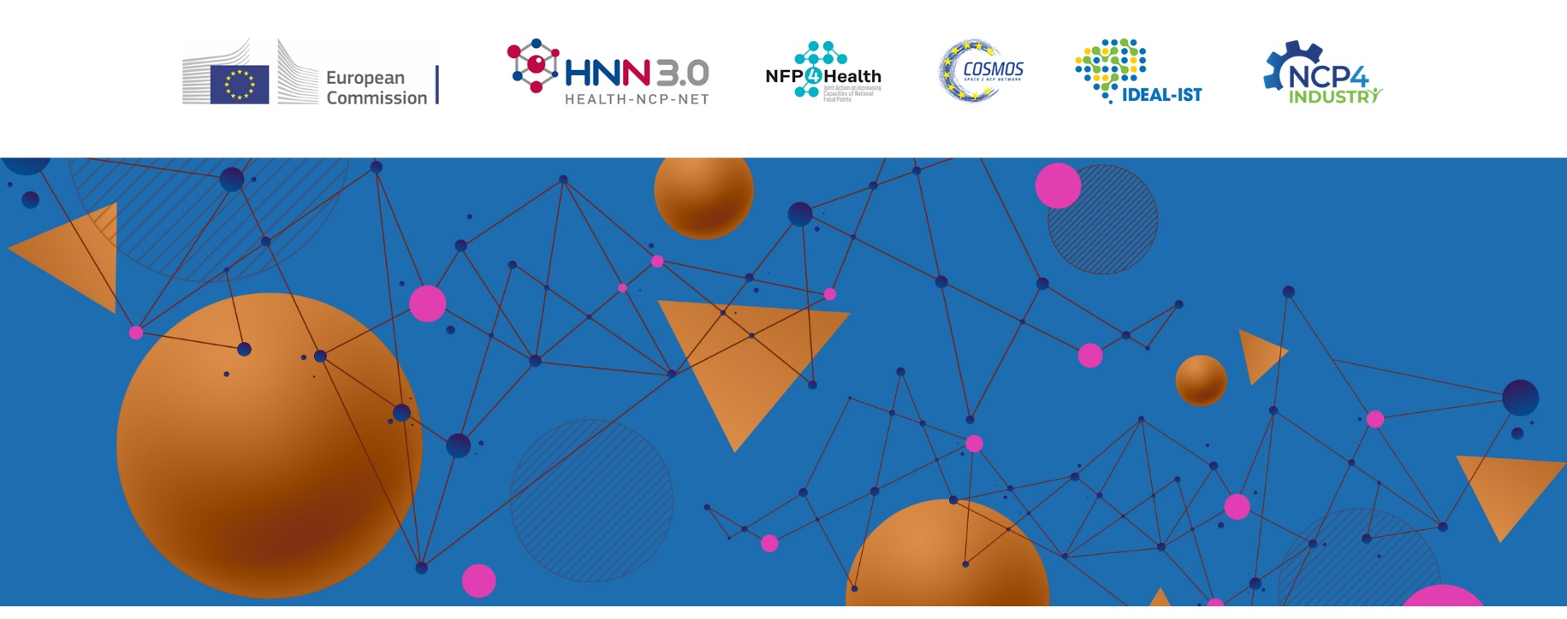

Synergies across the EU funding programmes managed by the European Health and Digital Executive Agency (HaDEA)

20 JUNE 2023 (h. 09:30 – 13:00 CET)

Hybrid event: online and at the ISS - Italian National Institute of Health*
Registration: https://forms.office.com/e/es7gvwVfpf

*ISS - Italian National Institute of Health | Address: Sala Pocchiari, Viale Regina Elena, 299, 00161 Roma

On the 20th June 2023, the European Health and Digital Executive Agency – HaDEA, is organizing in Rome the event Synergies across the EU Funding Programmes managed by the European Health and Digital Executive Agency (HaDEA) in collaboration with the networks of Horizon Europe National Contact Points for Cluster 1 (HNN 3) and Cluster 4 (COSMOS, IDEAL-IST, NCP4INDUSTRY) and the network of the EU4Health National Focal Points (JA NFP4Health). The event will be hosted by the Italian National Institute of Health – ISS, Viale Regina Elena, 299, 00161 Roma.

The event is aiming at promoting the European Programmes implementated by HaDEA in order to stimulate synergic actions and cooperation among the Horizon Europe (Cluster 1 Health and Cluster 4 Digital Industry and Space) EU4Health and Digital Europe’s networks and the relevant Stakeholders at the european level.
Marina Zanchi – Director General HaDEA will introduce the sessions dedicated to the presentation of HaDEA’s role to implement actions that strengthen Europe in the domains of health, food safety, digital technologies and networks, industrial capacities and space.
In order to highlight the impact of the participation to the European processes, the second part will be dedicated to the presentation of practical examples of successful management of European projects in synergy with other programmes.
With a view of supporting the networking and cooperation activities among the National Contact Points/Focal Points and the external Stakeholders, the Programmes managed by HaDEA’s respective networks such as JA NFP4Health, HNN3.0, COSMOS, IDEAL-IST and NCP4INDUSTRY will be presented during the last session of the event.

The event will be organized in hybrid modality. However, participation in presence is strongly encouraged.
Concurrently, on the 19th June will be organized a closed workshop targetting the National Focal Points and the National Contact Points of the Programmes managed by HaDEA and their networks respectively (JA NFP4Health, HNN3.0, COSMOS IDEAL-IST, NCP4INDUSTRY.

