Training for researchers
who want to improve their scientific writing

Training sessions to be taken separately or together during one week
Workshop on critical reading; discussion of texts brought by participants (1 day)
Writing Course 1: ′Effective development and writing of scientific manuscripts′ (2 days)
Writing Course 2: ′Manuscript writing − from good to excellent′ (2 days)

Guaranteed result: clearer, easier-to-read manuscripts with fewer words to proofread!

The workshop and courses can have maximum 12 participants.

Target group: Researchers in the life sciences; writers, editors and supervisors involved in basic or applied research designed to explore, describe or explain.
Times (9 am−4 pm each day), place, price and registration autumn 2017
Workshop: 11. September
Writing Course 1: 12 - 13 September
Writing Course 2: 14 - 15. September
A full concentrated week of training is most useful, but each session can be taken separately and still be valuable.
Place: Department of Global Public Health and Primary Care, Kalfarveien 31 (room will be announced later)
Price per training session: 2000 kr./day; i.e. 10000 kr. for a full week of training. For the writing courses, the price includes binders with slides and literature references.
How to register: https://skjemaker.app.uib.no/view.php?id=3736856

Comments from participants in training events
The course was very interesting, productive, relevant, useful and well structured. Nice references for continued work. Good examples point to pitfalls and show how to avoid them. I got a lot of helpful tips for developing a high-quality manuscript. Good balance between presentations and exercises. To work with one’s own project is very good, going through exercises in plenum was especially important, as it raises awareness about language issues. The course will save me a lot of time on manuscript writing in the future, since I now have appropriate tools and more confidence. To the point advice. Fills a need, no other courses like these. I find I have developed a much more critical eye, and I do believe this will be very useful both in manuscript writing and in research in general. The workshop was a useful preparation for the writing courses and should be taken first.
 | 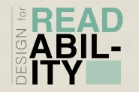 | 
http://lmcdegreeblog.lmc.gatech.edu/wp-content/uploads/2014/01/green8.5x11_1.jpg, http://designshack.net/wp-content/uploads/readability-lede.jpg, http://sustainablenonprofits.org/wp-content/uploads/2015/07/articles.jpg
Course leader − Kari Skinningsrud, bilingual (English and Norwegian)
• MSc (chem) from NTNU (Norwegian University of Science and Technology)
• Experienced trainer in scientific writing for Universities in Norway and abroad,
and for professional medical writers at biannual EMWA (European Medical
Writers Association) conferences.
• Has been a medical writer for pharmaceutical industry − as an employee and freelancer − for more
than 15 years, and has an advanced EMWA certificate of medical writing
• Member of EMWA’s professional development committee (www.emwa.org) since 2013.
• Invited speaker on the topic ′manuscript writing′ at the ESMO (European Society of Medical
Oncology) Young Oncologist Forum, in Madrid 2014.

Preparations and what you will learn
For all the training events, you will be asked to bring a paper of relevance for your research, published in a journal considered to be good in your field. You can be, but do not have to be an author of the paper/text you submit. Your selected text should be sent to the course leader well in advance of the training events.

Writing Course 1: ′Effective development and writing of scientific manuscripts′
Preparations. From your selected paper, you will be asked to send the following to the course leader:
a purpose statement (aim or hypothesis), and a figure (and legends) or table presenting results.
You will learn about how to increase the impact of publications by clarifying knowledge gaps and formulating effective purpose statements; to write concisely by using an outline format; to develop a storyline, and how to tackle main challenges within the standard (IMRaD/IRDaM) article sections. You will also learn to work more efficiently by developing content in a gradual stepwise manner, and by having a strategy for how to work with co-authors.

Writing Course 2: ′Manuscript writing − from good to excellent′
The course content is based mainly on the texts that participants send the course leader in advance.
Preparations. Read the text you submit carefully and critically. Make notes about issues in the discussion section that impede reading, and suggest improvements.
You will learn about characteristics of good writing, use of discourse features to link information and create flow and coherence; how to avoid monotony; to write and structure discussion sections more in depth than in Course 1; to improve titles, and how to communicate with editors.

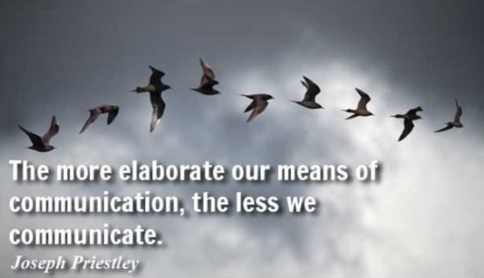 | 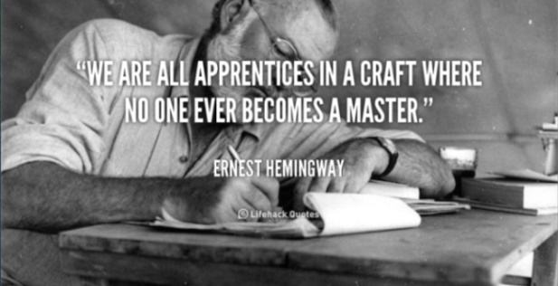
http://quotes.lifehack.org/media/quotes/quote-Ernest-Hemingway-we-are-all-apprentices-in-a-craft-103398.png , http://www.brainyquote.com/quotes/quotes/j/josephprie335782.html



