Invitasjon til UiB sin andre årlige læringskonferanse 2016:
Motivasjon for læring i høyere utdanning
Program:
Torsdag 20 . oktober 2016

8.30 – 9.00 Registrering/kaffe

9.00 – 10.30 Plenumsforedrag: Edward L. Deci
Promoting Optimal Motivation in Higher Education: A Self- Determination Perspective

10.30 – 10.45 Pause

10.45 – 11.20 Flipped classroom: Erfaringer fra et kurs i produktutvikling
Herbjørn Nysveen, professor, Institutt for strategi og ledelse, NHH
Arild Raaheim, professor, Institutt for pedagogikk, UiB

11.20 – 12.00 Hvilke effekter har teknologi på studentenes motivasjon og
Læring?
Lucas Jeno, stipendiat, Institutt for biologi, UiB

12.00 – 13.00 Lunch
13.00 – 15.00 Workshop: Self-Determination Theory: Edward L. Deci

Presentasjon av keynote:
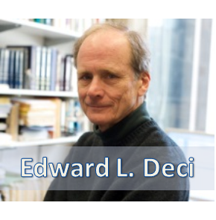
Edward L. Deci is a Professor of Psychology and Gowen Professor in the Social Sciences at the University of Rochester, and director of its human motivation program. He is well known in psychology for his theories of intrinsic and extrinsic motivation and basic psychological needs. With Richard Ryan, he is the co-founder of self-determination theory (SDT), an influential contemporary motivational theory. Self-determination theory is a macro theory of human motivation that differentiates between autonomous and controlled forms of motivation; the theory has been applied to predict behavior and inform behavior change in many contexts including: education, health care, work organizations, parenting, and sport. (Wikipedia)

