
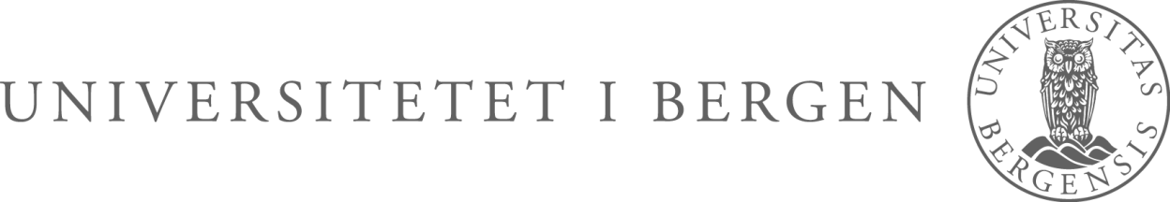
The Faculty of Medicine and Dentistry arranges a Career Day for PhD candidates and postdoctors at the faculty.

PROGRAM FOR THE DAY

10.00 – Welcome by Professor and Vice Dean for research education –
Roland Jonsson, the Faculty of Medicine and Dentistry

10.15 – CV and application writing – Rønnaug Tveit, Career Centre

11.00 – My way! Presentations from former PhD candidates
from the faculty

- Bengt Åge Borge – advisor in environmental health, Askøy Municipality
- Arnt Ove Hovden – Medical Manager, Boehringer Ingelheim Norway
- Vibeke Ansteinsson – research leader, Centre of Competence East
- Mette Tollånes – chief physician at Norwegian Institute of Public Health (Folkehelseinstituttet)

12.15 – Lunch and stands from Bergen University College, University of
Bergen, Norwegian Institute of Public Health, Boehringer
Ingelheim, Centre of Competence East, Helse Bergen, Bergen
Municipality, NIFES

14.00 – End of program
CAREER DAY
Thursday 6 October at 10-14 AUD 4 BB-building

